Why worry about stormwater? (Years 5 and 6)
  - Lesson plan
Victorian Curriculum F–10 links:
Levels 5 and 6
Geography
Geographical Knowledge
Factors that shape places and influence interconnections
Environmental and human influences on the location and characteristics of places and the management of spaces within them
Science
Science Understanding
Science as a Human Endeavour
Scientific understandings, discoveries and inventions are used to inform personal and community decisions and to solve problems that directly affect people’s lives
Chemical sciences
Solids, liquids and gases behave in different ways and have observable properties that help to classify them
Design and Technologies
Technologies and Society
Investigate how people in design and technologies occupations address competing considerations, including sustainability, in the design of solutions for current and future use
Materials and technologies specialisations
Investigate characteristics and properties of a range of materials, systems, components, tools and equipment and evaluate the impact of their use

Introduction
In natural environments, rainwater mostly evaporates, gets absorbed by plants or soaks into the ground. Urban development dramatically changes these processes, clearing land of vegetation and covering it with 'hard' or impervious surfaces that cannot let water through.
As a result, rainwater runs off these surfaces, through stormwater drains and straight into our waterways—as polluted stormwater—in a very short time. This changes the timing, speed and volume of water flows, which can affect our waterways and bays.
In this lesson plan, students investigate stormwater processes in their local catchment, stormwater management in Melbourne and innovative water sensitive urban design (WSUD) applications which address some of the issues. They also redesign a section of local guttering and drain using WSUD principles and build a model of their design.
The Stormwater Interactive Model is an educational model of an urban catchment that demonstrates the impact of stormwater on our rivers, creeks and bays. The water flows over the landscape, picking up pollutants along the way, washing them into our rivers and creeks and eventually into our bay.
For more information about the Stormwater Interactive Model and other school activities at the Edithvale-Seaford Wetland Education Centre, go to <http://www.melbournewater.com.au/getinvolved/education/programs/ETPtours/Pages/Visit-Eastern-Treatment-Plant.aspx>

Activity 1: Our local water catchment
Students research features of their local catchment region using Melbourne Water’s interactive Your Local Waterway website, profile local creeks and consider implications for the health of waterways that feed the catchment.

Activity 2: Managing stormwater
Students research city design features for managing stormwater. They identify how water from rains flows along roadside gutters and drains and investigate who is responsible for drainage features.

Activity 3: Water sensitive urban design in action
Using a local site, students investigate, design and build a model of a redesigned roadside gutter and drain to address water quality issues. Their redesign is based on water sensitive urban design (WSUD) principles.

Activity 1: Our local water catchment
Students research their local catchment region, profile local creeks and consider implications for the health of waterways that feed the catchment.

Duration
Two sessions

Equipment
Per group: one copy of the Student worksheet: my catchment area
Interactive whiteboard or data projector, if possible

Preparation
Students will need access to the internet for this activity.

Activity steps
- Begin by asking students to name any local rivers, creeks, wetlands and any other waterways they know of in their local area. List these on the whiteboard. Probe students’ understanding about these waterways using questions such as:
- Where does the water in the waterways originate?
- Where does the water in the waterways travel to?
- How are the wetlands replenished with water?
- Explain that we all live in a catchment area and that Melbourne Water looks after the catchment regions of Melbourne. Melbourne Water defines a catchment as: ‘The area of land drained by a creek or river system, or a place set aside for collecting water which runs off the surface of the land. Catchments provide the source of water for the dams and reservoirs in which our drinking water is collected’. (Melbourne Water Glossary)
- Highlight two types of catchments:
Natural catchment: When it rains, hails or snows (precipitation) in natural catchments some of the water flows downhill into creeks, rivers, lakes and reservoirs. Other water soaks into the soil where it may become groundwater and slowly seep into waterways too. Some of the water becomes water vapour when it evaporates from the soil or is taken up by plants, such as trees, and evaporates through the leaves (transpiration). The water flow in a natural catchment is generally slow and consistent.
Urban catchment: In an urban catchment there are harder surfaces. Roads and paving and buildings stop the water from soaking into the soil and make it run off more quickly than in the bush. There are fewer plants and trees to slow down the run-off and to evaporate the water. Water flows quickly, and often in large amounts, into gutters and drains, which are directly connected by pipes to the waterways.
- Provide students with the Student worksheet: my catchment area and explain that they will be researching their local catchment area using the Your Local Waterway website at <www.waterwatchmelbourne.org.au/content/your_local_waterway/your_local_waterway.asp>. Click on the map to find out more about your local catchment.
- As a class, discuss the different aspects of the research and clarify student understanding of the research task. Depending on computer availability, students work in pairs or small groups to complete the research.
- At the end of the task, as a class, share key research information about the local catchment and begin to develop a ‘Class local catchment profile’ for recording all key local catchment information. If you are using an interactive whiteboard you may allow for the inclusion of appropriate facts, web links and images.
- Ask students to identify which creeks, rivers and wetlands are closest to the school. Students conduct a map search using a street directory such as Melway or Google Maps, checking for accuracy of their ideas. They can use the map scale to calculate the shortest distances between the school and the creeks and rivers:
- as the crow flies
- by road or foot.
Add this information to the ‘Class local catchment profile’.
- Using local knowledge and the directory key, students identify where creeks or rivers intersect with roads, footpaths and railway lines. Establish a list of the roads that cross each creek or river in the area nearest the school. Students establish how the roads cross the waterway. Crossings may include a bridge, footbridge, drain or channel. Discuss issues for the waterway’s health at these crossings.
- This activity could be extended to include distances from the student’s home to the nearest creek or river with information added to the Class local catchment profile.
- If possible, organise an observational site visit to the local river or creek, waterway or wetland, to record key features.
- Using the ‘Class local catchment profile’ identify implications for the health of waterways that feed the catchment such as litter and pollution from roads crossing the waterway. Also suggest possible solutions or actions to reduce the identified risks to the rivers and creeks.

Resources

Your Local Waterway, Healthy Waterways Waterwatch Program, <www.waterwatchmelbourne.org.au/content/your_local_waterway/your_local_waterway.asp>

Know Your River (Information on Yarra, Maribyrnong and Werribee Rivers and Dandenong Creek), Healthy Waterways Melbourne Water, <http://melbournewater.com.au/getinvolved/education/knowyourriver/Pages/Know-your-river.aspx>

Waterways comparison, Healthy Waterways Waterwatch Program, <http://www.waterwatchmelbourne.org.au/content/activities_and_events/waterways_comparison/waterways_comparison.asp>

Note: This task could be used for assessment purposes to assess student understanding of the geographic language to identify and describe physical characteristics of local environments depicted by different kinds of maps and diagrams.

Activity 2: Managing stormwater
Students consider city design features for managing stormwater.

Duration
Two sessions

Equipment
For each group:
One set of Mystery envelopes (see below)
For each student:
One copy of Student worksheet: Drainage and flooding in Melbourne
Interactive whiteboard or data projector

Preparation
Prior to this activity, prepare enough Mystery envelopes (Student worksheet: Mystery envelopes) for groups of four students. Each Mystery envelope holds a collection of 4–6 different images which may be different. For example, different types of drains, roadside gutters, roofs, building gutters, tanks, stormwater pipes, roads and footpaths, creeks and rivers, the bay, wetlands, litter in drains, factories, farmland and waterways may be provided.

Activity steps
- Watch the video ‘Water Smart City at the Collingwood Children’s Farm’ [1:25] at <https://www.youtube.com/watch?v=0pEdAATvFGk>. Before they watch the video, cue the students to look for the answers to these questions:
- What are some of the problems caused by stormwater in urban areas? (The rain doesn’t soak into the ground. Because of all the hard surfaces, the rainwater flows straight out into the bay.)
- What solutions to the problems were highlighted in the video? (Green roofs, using water tanks, porous paving)
- Working in groups of four, students receive a Mystery envelope with a number of images inside. The group is to discuss the images and decide on a creative way to tell how the images are connected and the implications for managing stormwater and looking after our rivers and bays.
- Each group shares their ‘story’ with the class. The class agrees on a set of key ideas that arise from the story-sharing, for example:
Teacher tips
Run-off describes the water from rain, snowmelt or irrigation that flows over the land surface and is not absorbed into the ground, instead flowing into streams, other surface waters or land depressions.
Stormwater can come from any precipitation and is surface run-off that is transported eventually to the stormwater system.
- run-off is rain or water that does not soak into the ground and flows from a catchment into a river, stream, lake or reservoir
- different surfaces produce different amounts of run-off
- stormwater is carried in pipes and drains to rivers and the bay
- stormwater can be polluted, which harms rivers and the bay
- we can change what we do with stormwater.
- Ask students what they have observed when rain falls at school and home. For example, puddles form, muddy areas appear, water runs across the netball courts, gutters overflow. Ask students if there are differences when there are different types of rainfall, for example, light showers versus a thunderstorm. As a result of the discussion establish an understanding of the key terms: run-off and stormwater. Your local council may be able to supply the class with maps of the local stormwater drainage system, including pipes and litter traps as well as surface channels, creeks and wetlands.
- For the next part of the activity, students will need access to a computer. Alternatively the teacher can show the website using the interactive whiteboard or a laptop and data projector.
- Students explore what happens when it rains in urban areas, how houses and parks are affected and the consequences of different amounts of stormwater on the community, and the impacts of stormwater pollution. They complete the Student worksheet: Drainage and flooding in Melbourne, recording what they find out about the responsibilities of individuals, councils and other organisations that work together on planning and responding to different degrees of rain, including floods.
- In pairs or small groups students use the information they have gathered from the websites to develop stormwater management statements which highlight what people can do to minimise the impacts of stormwater and flooding. For example, individuals can install rainwater tanks to capture rainwater to use for watering the garden and flushing the toilet; councils sweep streets, monitor building works and clean out roadside drains to help keep the stormwater system clear of rubbish. Students should consider:
- urban design
- environmental impacts and solutions
- individual and community responsibilities.
- Display statements and provide students with an opportunity to speak to their statements. The class can vote on the statements with the most powerful message for managing stormwater.

Resources
Melbourne Water
Stormwater, <http://www.melbournewater.com.au/whatwedo/protectrivers/improving-river-health/Pages/Stormwater.aspx>
Drainage system, <http://melbournewater.com.au/whatwedo/manageflooding/Pages/Drainage-system.aspx>
Drainage and flooding factsheet, <http://melbournewater.com.au/whatwedo/manageflooding/Documents/Drainage_Flooding_Factsheet.pdf>

Activity 3: Water Sensitive Urban Design in action
Students investigate their local area and identify how water from rains flows along roadside gutters and drains. Discuss issues associated with stormwater and the effect on waterway water quality. Investigate, design and build a model of a redesigned roadside gutter and drain to address water quality issues.

Duration
Two sessions

Equipment
For each group:
Large plastic soft drink bottle with the bottom cut off
Materials to put in the bottle such as soil, sand, mulch and different sized pebbles
Container in which the inverted drink bottle sits while it is draining water
Stopwatch or stopwatch app
A container of water containing grass clippings and dirt
Watering can

Preparation
Collect images of the built and natural features including parks or bushland, or strips of roadside vegetation in the local area. Ensure that safety guidelines are followed.

Activity steps
- Display the images of local built and natural features. Students identify changes in the way water flows in the urban environment by contrasting the way water would have flowed when the environment was in its natural state. Compare the built and natural environment in the local area or show some photographs of remaining natural spaces such as park or bushland, or strips of roadside vegetation. (Optional: students can bring a photograph which depicts a natural space and another that depicts a built up area.)
- Visualise with the students what the local area may have been like 150 years ago (Optional: use historical photographs or paintings for reference if they are available.)
- View artwork of early Melbourne to discuss the natural environment. You can find the following digital curriculum resources in Scootle <https://www.scootle.edu.au>. Teachers can register for free using your school email address.
- R8216 'Golden summer, Eaglemont', 1889
- R6807 'Melbourne in 1838'.
Many of the natural areas have been replaced by hard surfaces such as roads, buildings, footpaths, car parks. Raise the following questions. Discuss student responses and guide the discussion as required.
  - What happens to water flow from heavy rains in a natural area?
Generally water in the natural environment seeps into the ground while some flows across the surface and flows towards waterways. Vegetation and rocks slow the speed of water run-off. Wetlands often provide a natural filter to water flowing across the surface and also slow the pace of the water, therefore avoiding erosion.
  - What is the effect of replacing natural spaces with the built environment?
There are many more hard surfaces where water does not seep through (permeate).
  - What is the purpose of roadside gutters and drains?
In the urban environment water that flows over hard surfaces such as roads, footpaths, driveways and car parks is channelled through a series of roadside gutters and drains which lead to our waterways and finally flow out into the ocean. This stormwater network of gutters and drains is to help avoid or at least reduce flooding.
  - What are some issues with stormwater flowing into our waterways?
One issue is the speed and volume of water that flows into the waterways. After heavy rains, fast-flowing water entering the waterway can cause erosion. Another issue is the pollutants and particles (suspended solids) that are carried into the waterway via stormwater, which affect water quality.
- Students identify a section of their local roadside guttering and drain that they will redesign. Students take a photograph or draw the site. Show examples of existing water sensitive urban design (WSUD) using bio-retention where stormwater treatment is integrated into the landscape (refer to Resources).
- Prior to starting their design, students investigate the effect of particular natural materials on water flow and how these may be incorporated into their design. Natural materials include soil, sand, mulch and different-sized pebbles.
- Working in groups, students investigate the flow of water through a plastic soft drink bottle with the bottom cut off. Sit the inverted bottle in a container so that the water is captured:
- Time the flow before and after adding stones to a container.
- Observe the passing of dirty water containing grass clippings and other particles. Do the stones trap some of the particles?
- Discuss how vegetation slows the flow of water and soaks up water in soils. Use a pot-plant or section of the school garden to observe the effects of water flows.
- Students use the results of their investigations to devise a plan and draw their design. In their design they address how to:
- slow the water flowing into the drain
- reduce the amount of water flowing into the drain
- filter out some of the pollutants and particles
- ensure their design does not increase the chance of flooding.
- Students use a range of natural and recycled materials to create their design. They share their designs and explain how it addresses the stormwater issues and how it is an improvement on the existing design. They evaluate their design and discuss any changes they would make as a result of feedback and discussion.

Resources
For information about water sensitive urban design and its applications, go to:
Raingardens, Melbourne Water
<http://www.melbournewater.com.au/getinvolved/protecttheenvironment/raingardens/Pages/Raingardens.aspx>
Evaluating Options for Water Sensitive Urban Design – A National Guide, Australian Government Department of Sustainability, Environment, Water, Population and Communities, <https://www.environment.gov.au/system/files/resources/1873905a-f5b7-4e3c-8f45-0259a32a94b1/files/wsud-guidelines.pdf>
Stormwater management (Water Sensitive Urban Design), Melbourne Water
<http://www.melbournewater.com.au/Planning-and-building/Stormwater-management/Pages/Stormwater-management.aspx >
<http://www.melbournewater.com.au/Planning-and-building/Forms-guidelines-and-standard-drawings/Documents/Water-Sensitive-Urban-Design-factsheet.pdf>
Healthy Waterways Waterwatch, www.waterwatchmelbourne.org.au/
Bioretention basins, Gold Coast Planning Scheme Policies, <www.goldcoast.qld.gov.au/gcplanningscheme_policies/policy_11.html#guidelines>

Student worksheet: My catchment area (Activity 1)
Research facts about your local catchment using the website ‘Your Local Waterway’. Go to <www.waterwatchmelbourne.org.au> and click on ‘Find out about your local creek’. This will take you to ‘Your Local Waterway’. Click on the map to find out more about your local catchment. Use this table to record your information.
Researchers’ names:
My catchment area
Name of river or creek | Two important facts about the river or creek | Two key risks to the river or creek

Student worksheet: Mystery envelopes (Activity 2)
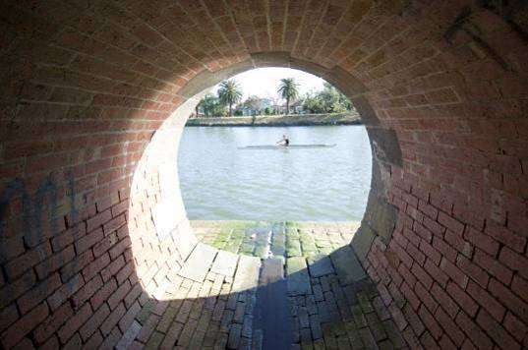  Stormwater drain |  | 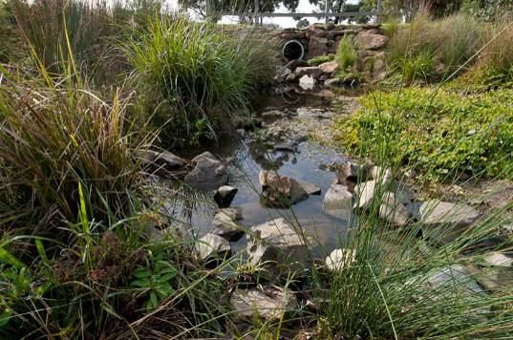  Stormwater drain
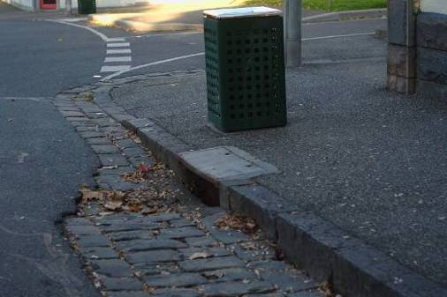  Roadside gutter |  | 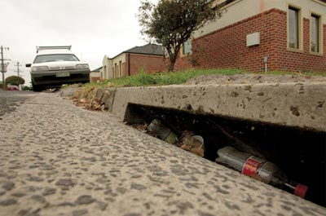  Roadside gutter with litter
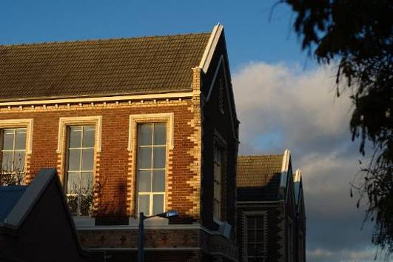  Roof |  | 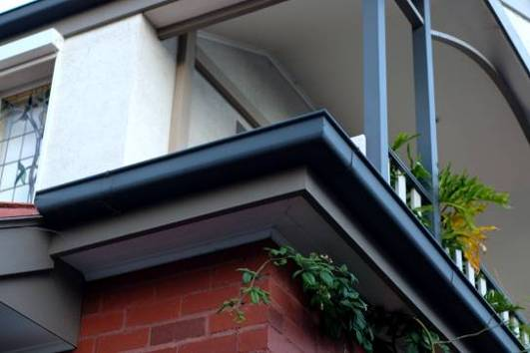  Roof gutter
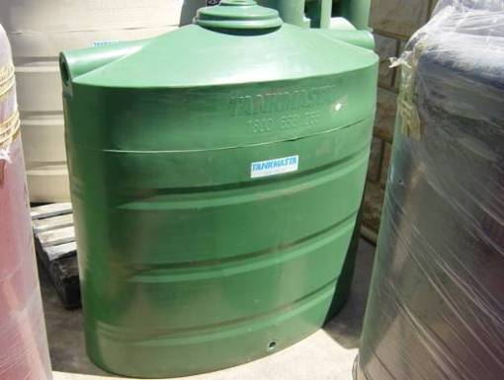 Rainwater tank |  | 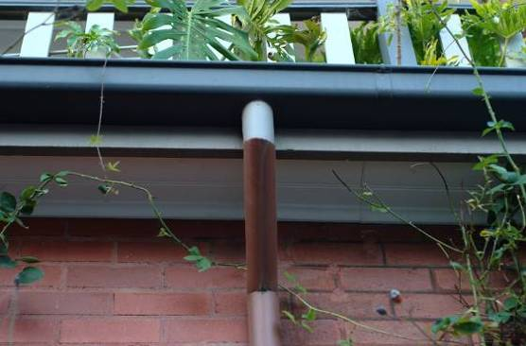  Stormwater pipe
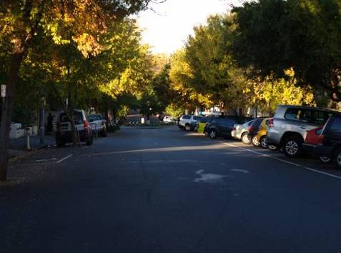  Road | 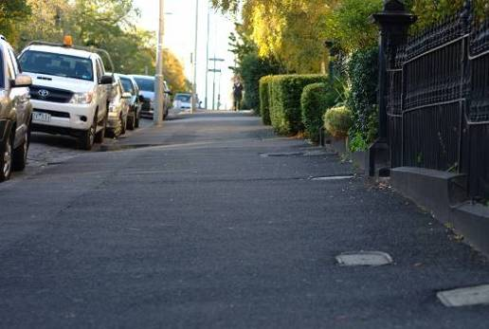  Footpath
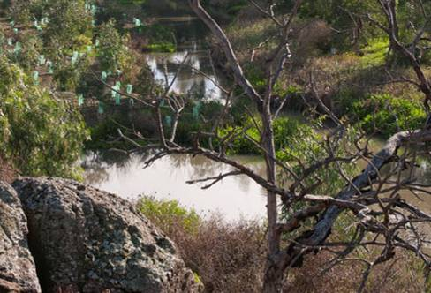  Creek | 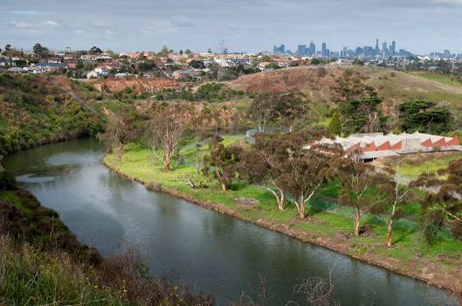  River
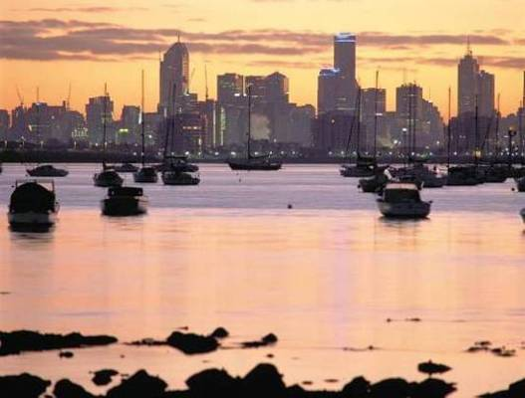  The Bay | 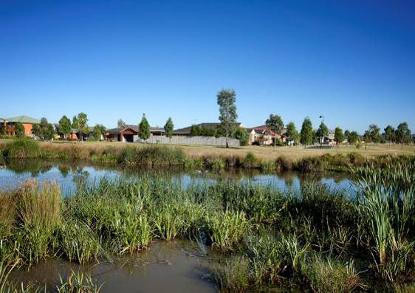  Wetlands
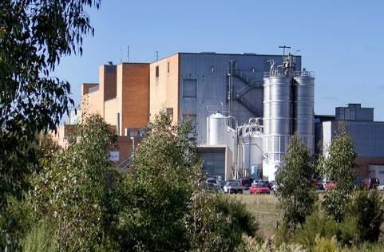  Factory | 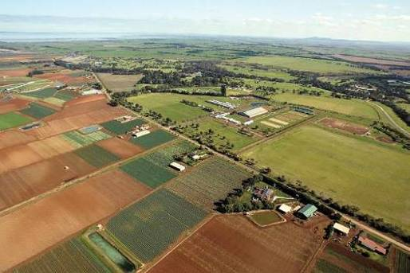  Farmland

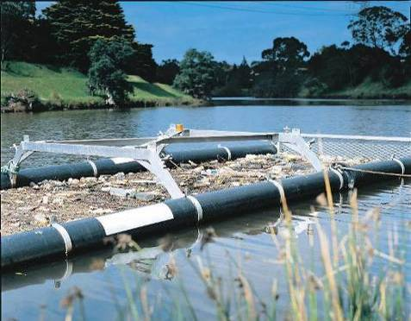  Litter trap | 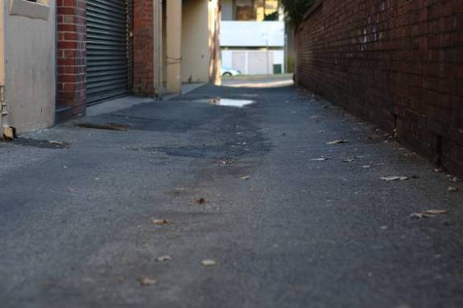  Hard paving
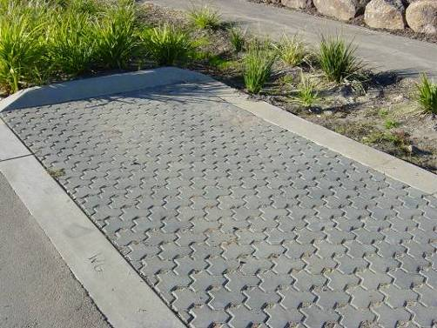
Porous paving

Student worksheet: Drainage and flooding in Melbourne (Activity 2)
Investigate the drainage system in Melbourne, using the following resources:
Drainage system at <http://melbournewater.com.au/whatwedo/manageflooding/Pages/Drainage-system.aspx>
Drainage and flooding factsheet, <http://melbournewater.com.au/whatwedo/manageflooding/Documents/Drainage_Flooding_Factsheet.pdf>
Use this worksheet to record facts, ideas and information. There are blank spaces for you to use for your own ideas.
What happens when it rains? | What facts, ideas and information did I find out about this? Whose responsibility?
Rainfall run-off from different surfaces
Drains
Parks
Pollution
Stopping pollution
Role of the council
Urban design ideas for better use of rainwater
Wetlands

Victorian Curriculum and Assessment Authority (VCAA) <http://victoriancurriculum.vcaa.vic.edu.au/> Accessed 14 August 2016.

